A FIELD PROJECT REPORT ON

AI-BOT

Submitted in partial fulfilment of the requirements for the award of the degree

BACHELOR OF TECHNOLOGY

in

COMPUTER SCIENCE & ENGINEERING

Submitted by

|  |  |
| --- | --- |
| R.TEJA | (231FA04398) |
| M.PREETHI | (231FA04A45) |
| CH.JASWIKA | (231FA04A73) |
| G.UMA DEVI | (231FA04A85) |
| M.KAVYA | (231FA04A97) |

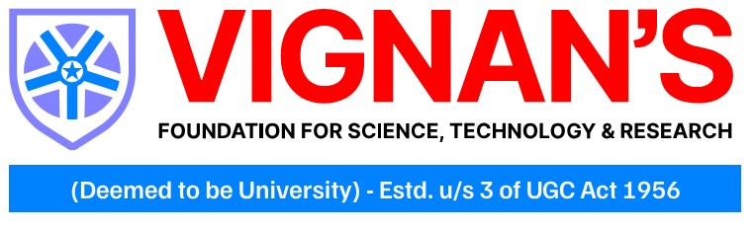

Department of Computer Science & Engineering

School of Engineering

Vignan’s Foundation for Science, Technology and Research (Deemed to be University) Vadlamudi, Guntur, Andhra Pradesh-522213, India

APRIL – 2025



CERTIFICATE

This is to certify that the field project entitled “AI-BOT” being submitted by (R. Teja & 231FA04398), (M. Preethi & 231FA04A45), (Ch. Jaswika & 231FA04A73), (G. Uma Devi & 231FA04A85), and (M. Kavya & 231FA04A97) in partial fulfilment of Bachelor of Technology in the Department of Computer Science & Engineering, Vignan’s Foundation For Science Technology & Research (Deemed to be University), Vadlamudi, Guntur District, Andhra Pradesh, India, is a Bonafide work carried out by them under my guidance and supervision.

|  |  |
| --- | --- |
| **Head of the Department** | **Guide** |

DECLARATION

We hereby declare that our project work described in the field project titled “AI-BOT” which is being submitted by us for the partial fulfilment in the department of Computer Science & Engineering, Vignan’s Foundation for Science, Technology and Research (Deemed to be University), Vadlamudi, Guntur, Andhra Pradesh, and the result of investigations are carried out by us under the guidance of Mr. Pavan Kumar.

|  |  |  |
| --- | --- | --- |
| R.TEJA | (231FA04398) | Signature |
| M.PREETHI | (231FA04A45) | Signature |
| CH.JASWIKA | (231FA04A73) | Signature |
| G.UMA DEVI | (231FA04A85) | Signature |
| M.KAVYA | (231FA04A97) | Signature |

|  |  |  |  |
| --- | --- | --- | --- |
|  | |  |  |
|  |  |  |  |
|  |  |  |  |
|  |  |  |  |
|  |  |  |  |
|  |  |  |  |
|  |  |  |  |
|  |  |  |  |
|  |  |  |  |
|  |  |  |  |
|  |  |  |  |
|  |  |  |  |
|  |  |  |  |
|  |  |  |  |
|  |  |  |  |
|  |  |  |  |
|  |  |  |  |
|  |  |  |  |
|  |  |  |  |

I : INTRODUCTION:

In today's digital era, conversational interfaces have become essential for creating engaging, interactive, and user-friendly experiences. The AI-Bot project is a web-based application designed to simulate real-time conversations between users and an intelligent virtual assistant. Built using modern web technologies like HTML, CSS, and JavaScript, the project not only demonstrates the fundamentals of responsive design but also emphasizes a seamless and dynamic user experience.

The AI-Bot project is more than just a technical exercise; it is an exploration into the potential of AI-driven interactions. It reflects current trends in conversational design and offers a platform to experiment with and refine the way users interact with technology. Whether for customer support, personal assistance, or just casual conversation, the AI-Bot sets the stage for innovative solutions that bridge the gap between human and machine communication.

Problem Definition

* In the current digital landscape, users increasingly expect fast, intuitive, and interactive communication with technology. Traditional customer service channels, static web pages, and outdated chat interfaces often fail to meet these demands, leading to frustration and inefficiency. Key issues include:
* Limited Interactivity: Many existing solutions do not provide dynamic, real-time engagement, which is crucial for resolving user queries effectively.
* Integration of Advanced AI**:** There is a gap in seamlessly integrating advanced AI capabilities into user-friendly platforms that can adapt to diverse contexts and needs.
* The AI-Bot project aims to address these challenges by leveraging modern web technologies to create a responsive, engaging, and scalable chat interface. This system not only improves the efficiency of digital interactions but also paves the way for further integration with sophisticated AI models, ensuring a more natural and effective communication experience for users.

Existing Systems

* Several existing systems have attempted to address user interaction through automated and semi-automated interfaces. These systems include:
* **Traditional bots:** Early chatbot implementations were rule-based and relied on predefined scripts to respond to user queries. While they could handle basic interactions, they often lacked the flexibility to deal with more complex or unanticipated inputs.
* **Virtual Assistants:**  
  Systems such as Siri, Alexa, and Google Assistant have pushed the envelope by incorporating advanced natural language processing and machine learning techniques. These assistants offer a higher degree of interactivity and can handle a variety of tasks beyond simple conversation. However, they are typically tied to specific ecosystems and require significant backend infrastructure.
* While these existing systems provide a variety of solutions for digital communication, each comes with limitations related to adaptability, scalability, or user experience. The AI-Bot project is designed to build on these foundations by offering a customizable, responsive, and user-friendly interface that can be integrated with more advanced AI models, ultimately aiming to bridge the gap between the simplicity of rule-based systems and the complexity of fully-fledged virtual assistants.

Proposed System

The proposed system is an AI-powered chat interface built using modern web technologies such as HTML, CSS, and JavaScript, offering a scalable and robust foundation for seamless user interaction. With a sleek, responsive design, it ensures a consistent experience across all devices, while interactive features like animated status indicators and a dynamic "thinking" animation enhance user engagement and provide real-time feedback. A built-in theme toggle allows effortless switching between light and dark modes, catering to individual user preferences. Engineered to handle both simple and complex queries, the system is capable of integrating advanced AI modules to facilitate natural, intelligent, and efficient conversations.

Literature Review

The literature review outlines the evolution of conversational systems from early rule-based bots to machine learning models that offer more natural responses. Recent hybrid approaches combine rule-based reliability with AI flexibility for smoother interactions. Research also emphasizes the role of user-friendly design elements like responsive layouts and real-time feedback in enhancing user experience. Ongoing advancements aim to make AI conversations more seamless and human-like.This review underscores the need for modern systems, like the proposed AI-Bot, which integrate advanced AI capabilities with user-friendly design to deliver efficient and natural conversational experiences.

2:SYSTEM REQUIREMENTS

Hardware & Software Requirements

1. Hardware Requirements:

* Client Devices: The application is designed for use on modern devices such as desktops, laptops, tablets, and smartphones. Any device capable of running a contemporary web browser is sufficient.
* Display: A screen with a minimum resolution of 1024×768 pixels is recommended for optimal viewing of the chat interface.

1. Software Requirements:

Development Tools: A code editor or IDE (e.g., Visual Studio Code, Sublime Text, or Atom) is recommended for editing the project files. A local server environment (such as Node.js with Express, or even simple HTTP server setups) may be useful during development and testing.

Software Requirements Specification ( SRS )

Overview:  
The SRS outlines the requirements for developing the AI-Bot project, detailing the functionality, performance, and constraints of the system. It serves as a guideline for developers, stakeholders, and testers to ensure that the final product meets the desired objectives.

Functional Requirements:

* The system is designed to support smooth user interaction by enabling message input through a dedicated text area, dynamically displaying AI-generated responses, and offering the option to clear chat history as needed. To enhance engagement and provide clarity during processing, the application includes real-time visual feedback, such as a “thinking” indicator that signals the system is generating a response. Additionally, theme management features allow users to switch between light and dark modes, ensuring a comfortable and personalized interface tailored to individual preferences.
* Non-Functional Requirements**:** The system prioritizes performance by ensuring quick responses with minimal latency, delivering a smooth conversational experience. Its intuitive and accessible design guarantees usability across devices, including desktops, mobiles, and tablets. Additionally, strong security measures are implemented to protect data transmission and uphold user privacy throughout all interactions.
* System Environment & Constraints: The system is developed using HTML, CSS, and JavaScript, and it is intended to run on modern web browsers like Chrome, Firefox, Safari, or Edge. It must operate reliably on devices with standard processing power and display resolutions of at least 1024×768 pixels.
* Assumptions & Dependencies: The project assumes stable internet connectivity for optimal performance. Future enhancements may include integration with advanced AI modules or cloud-based services, which may introduce additional dependencies and require further security measures

3.System Design: AI-BOT Application

The system is designed using a multi-layered architecture that separates concerns and enables scalability, maintainability, and ease of integration with future AI enhancements. The key layers include:

Presentation Layer (Frontend):

* User Interface: Built with HTML, CSS, and JavaScript, the interface is responsible for displaying chat messages, interactive animations, and real-time status indicators.
* User Interactions: Features such as the text input area, send button, clear chat, and theme toggle allow users to interact seamlessly with the bot.

Application Logic (Client-Side Scripting):

* Dynamic Message Handling: JavaScript handles the addition of new messages to the chat interface, applying animations and ensuring a smooth user experience.
* Real-Time Feedback: Components like the "thinking" indicator are triggered while waiting for a response from the AI module, providing visual feedback.

Integration Layer (Backend/API):

* AI Module Integration: Although the initial implementation focuses on the front-end experience, the architecture is designed to easily integrate with backend AI modules or cloud-based services for processing user queries and generating responses.
* API Communication: A RESTful API or WebSocket connection can be used to transmit user input from the frontend to the AI processing engine and receive responses in real time.

Technologies:

* Front-end: HTML5, CSS3, JavaScript (fetch).

Modules of System:

* Chat Interface Module: This module is responsible for rendering the conversation window. It displays both user and bot messages and handles visual aspects such as message formatting, animations (fade-in, pulse, bounce), and scrolling
* Input & Control Module: It manages user interactions, capturing input from the text area and processing commands such as sending a message, clearing chat history, and toggling between themes. This module ensures that user actions are seamlessly translated into system responses.
* Feedback & Status Module: This module provides real-time visual feedback to the user. It manages status indicators like online/offline status and the "thinking" animation that appears while the AI processes a request.
* Integration & API Module**:** Designed for future enhancements, this module serves as the bridge between the front-end interface and the backend AI processing engine. It handles communication via APIs or WebSocket connections, ensuring asynchronous data exchange and response delivery.
* Data Management Module: Responsible for managing the state of the application, this module handles chat history, user sessions, and preferences (like theme settings). It can also be extended to include logging and analytics for performance monitoring and user behavior tracking.
* Each module is designed to work cohesively, ensuring a responsive, user-friendly, and scalable system that can easily integrate advanced AI functionalities in the future.

UML Diagram:

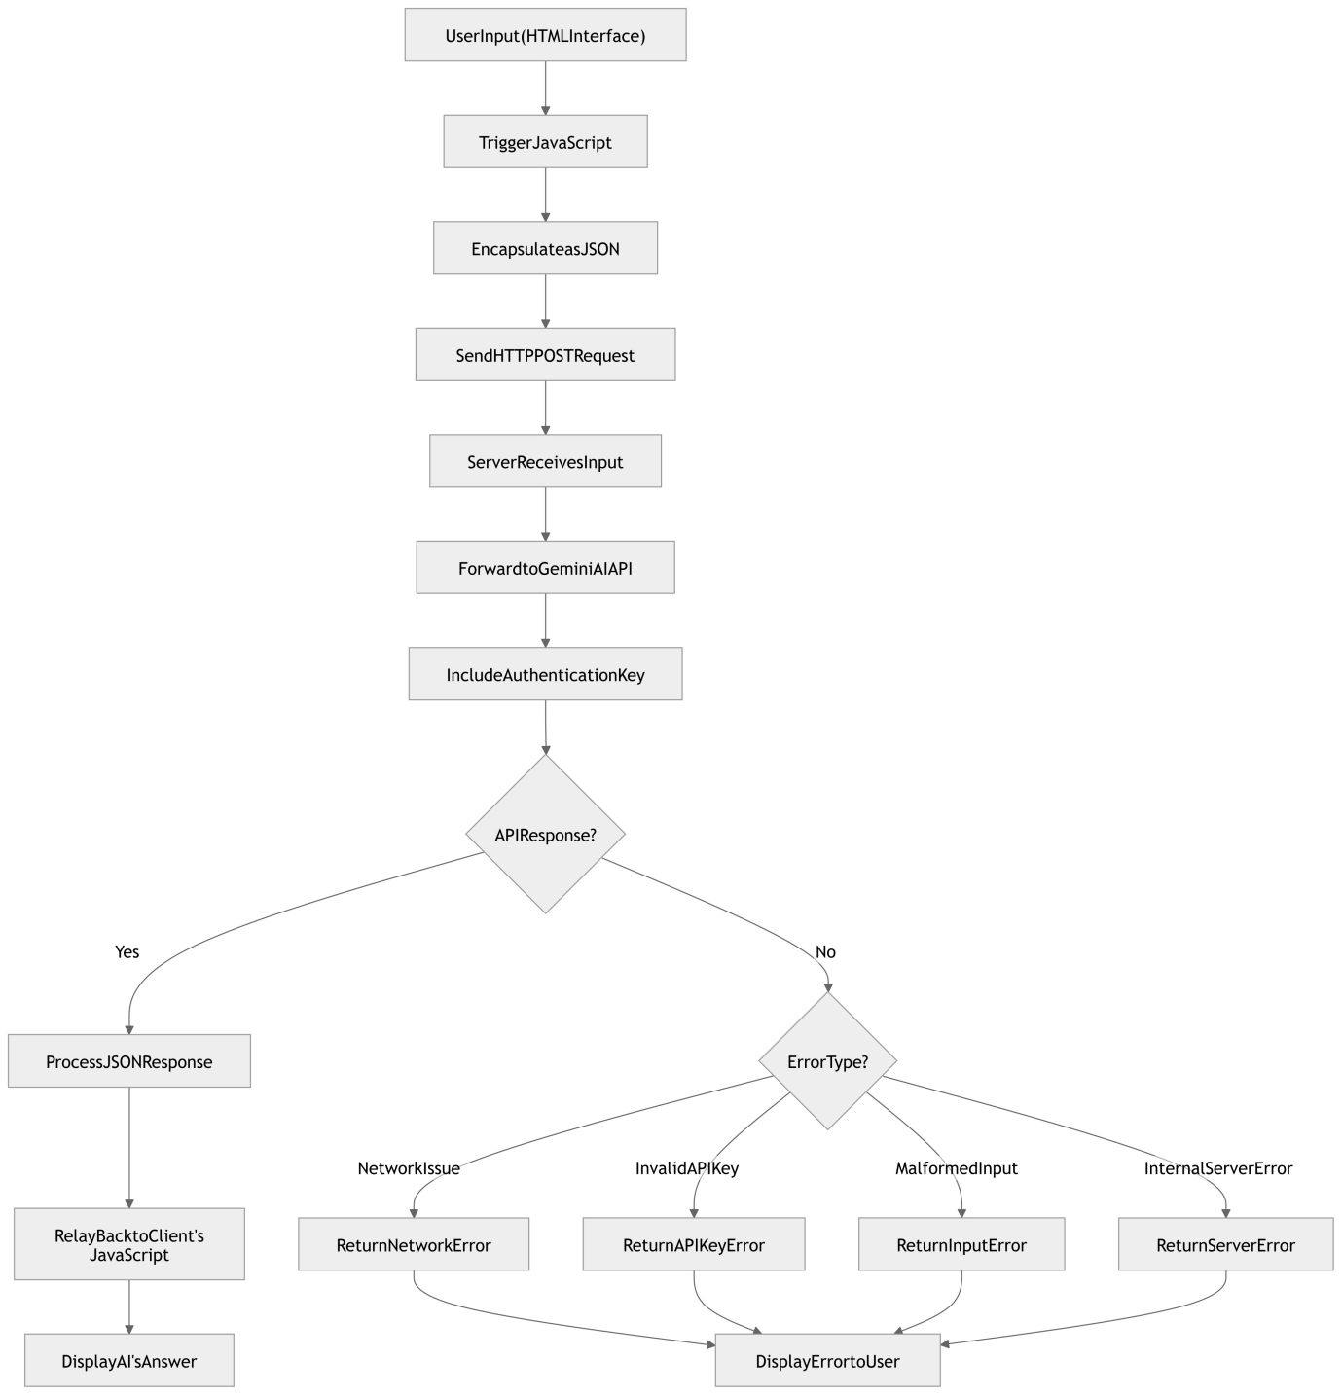Fig: Unified Modeling Language Diagram

Description:

* This image contains a UML flowchart that illustrates the internal workings of the AI chatbot system. The flow starts from UserInput(HTML Interface), and includes steps like:
* Trigger JavaScript
* Encapsulate as JSON
* Send HTTP POST Request
* Forward to Gemini API
* Check API Response
* Error Handling (network issues, API key error, malformed input, etc.)
* The flowchart clearly outlines both successful and error handling paths, ending with either a response being displayed or an error being shown to the user

Implementation Analysis of AI-Bot

The implementation of the AI-Bot involves three key components: HTML (UI Structure), CSS (Styling & Responsiveness), and JavaScript (Functionality & Interactions). The analysis below evaluates these components based on design, functionality, and performance.

1. Frontend Implementation (HTML)

Overview:

* The HTML file (testaibot.html) provides the structural layout of the bot.
* It includes a chat container, message display area, input field, and control buttons.
* External libraries like FontAwesome and Google Fonts enhance UI aesthetics.

Strengths:

* Clean and well-structured layout with semantic HTML.
* Responsive design elements for different screen sizes.
* Lightweight and efficiently rendered on web browsers.

2. Styling and UI (CSS)

Overview:

* The CSS file (styles123.css) defines the chatbot's visual appearance.
* Implements light and dark themes with smooth transitions.
* Uses CSS animations for better interactivity (e.g., blinking indicator, fading effects).

Strengths:

* Well-organized color themes with CSS variables.
* Mobile-friendly and responsive design.
* Attractive UI with modern animations.

3.Functionality & User Interaction (JavaScript)

Overview:

The JavaScript file (script123.js) controls message handling, UI updates, and user interactions. Features include sending messages, clearing chat history, toggling themes, and simulated bot response.

Strengths:

* Interactive and dynamic user experience.
* Efficient DOM manipulation for adding chat messages.
* Implements event listeners for smooth interactions.

Key Functional Features:

 User Message Handling:

* Captures user input and displays it in the chat interface.
* Prevents sending empty messages.

 AI Response Simulation:

Shows a "Thinking..." indicator before responding.

Auto-generates a placeholder response.

Theme Toggle:

Allows switching between light and dark modes dynamically.

Chat Clear Functionality:

Removes all previous messages from the interface.

4. Performance Analysis

Loading Speed: 🚀 Fast, as it is a client-side web application with no external API calls.

Resource Usage: ⚡ Optimized; only necessary scripts and styles are loaded.

Responsiveness**:** 📱 Works well on both desktop and mobile devices.

Scalability: 🔄 Can be extended with AI backend integration.

5. Security Considerations

No sensitive data handling, making it safe from security risks. Could implement input sanitization to prevent XSS attacks. Secure data storage could be added if user sessions are required.

4.Sample Code:

<!DOCTYPE html>

<html lang="en">

<head>

<meta charset="UTF-8" />

<meta name="viewport" content="width=device-width, initial-scale=1.0" />

<title>Gemini AI Assistant</title>

<!-- External CSS File -->

<link rel="stylesheet" href="styles123.css" />

<!-- External Fonts and Icons -->

<link rel="stylesheet" href="https://cdnjs.cloudflare.com/ajax/libs/font-awesome/6.4.0/css/all.min.css" />

<link rel="preconnect" href="https://fonts.googleapis.com" />

<link rel="preconnect" href="https://fonts.gstatic.com" crossorigin />

<link href="https://fonts.googleapis.com/css2?family=Inter:wght@300;400;500;600;700&display=swap" rel="stylesheet" />

</head>

<body>

<div class="container">

<div class="chat-container">

<div class="chat-header">

<div class="chat-header-title">

<div class="logo">

<div class="logo-pulse"></div>

<i class="fas fa-robot"></i>

</div>

<h1>AI-Bot</h1>

</div>

<div class="status-indicator">

<span class="status-dot"></span>

<span class="status-text">Online</span>

</div>

</div>

<div class="messages-container" id="messages-container">

<div class="message bot-message welcome-message">

<div class="message-avatar">

<i class="fas fa-robot"></i>

</div>

<div class="message-content">

<div class="message-text">

<p>Hello! I'm your Gemini AI assistant. How can I help you today?</p>

</div>

<div class="message-time">Just now</div>

</div>

</div>

<!-- Dynamic messages will appear here -->

</div>

<div class="input-container">

<div class="input-wrapper">

<textarea id="user-input" placeholder="Type your message here..." rows="1"></textarea>

<button id="send-button" class="send-button">

<i class="fas fa-paper-plane"></i>

</button>

</div>

<div class="features">

<button class="feature-button" id="clear-chat">

<i class="fas fa-trash-alt"></i>

<span class="tooltip">Clear chat</span>

</button>

<button class="feature-button" id="toggle-theme">

<i class="fas fa-moon"></i>

<span class="tooltip">Toggle theme</span>

</button>

</div>

</div>

</div>

</div>

<div class="thinking-indicator" id="thinking-indicator">

<div class="thinking-dots">

<div class="dot dot1"></div>

<div class="dot dot2"></div>

<div class="dot dot3"></div>

</div>

<div class="thinking-text">Thinking...</div>

</div>

<!-- Inline JavaScript for functionality -->

<script>

const sendButton = document.getElementById('send-button');

const userInput = document.getElementById('user-input');

const messagesContainer = document.getElementById('messages-container');

const clearChatButton = document.getElementById('clear-chat');

const toggleThemeButton = document.getElementById('toggle-theme');

const thinkingIndicator = document.getElementById('thinking-indicator');

sendButton.addEventListener('click', () => {

const text = userInput.value.trim();

if (!text) return;

const userMessage = createMessageElement(text, 'user');

messagesContainer.appendChild(userMessage);

userInput.value = '';

scrollToBottom();

showThinkingIndicator();

setTimeout(() => {

hideThinkingIndicator();

const botResponse = createMessageElement("This is a simulated AI response.", 'bot');

messagesContainer.appendChild(botResponse);

scrollToBottom();

}, 1000);

});

function createMessageElement(message, sender) {

const messageEl = document.createElement('div');

messageEl.classList.add('message', sender === 'user' ? 'user-message' : 'bot-message');

messageEl.innerHTML = `

<div class="message-avatar">

<i class="${sender === 'user' ? 'fas fa-user' : 'fas fa-robot'}"></i>

</div>

<div class="message-content">

<div class="message-text"><p>${message}</p></div>

<div class="message-time">${new Date().toLocaleTimeString([], {hour: '2-digit', minute:'2-digit'})}</div>

</div>

`;

return messageEl;

}

clearChatButton.addEventListener('click', () => {

messagesContainer.innerHTML = '';

});

toggleThemeButton.addEventListener('click', () => {

if (document.body.getAttribute('data-theme') === 'dark') {

document.body.removeAttribute('data-theme');

} else {

document.body.setAttribute('data-theme', 'dark');

}

});

function scrollToBottom() {

messagesContainer.scrollTop = messagesContainer.scrollHeight;

}

function showThinkingIndicator() {

thinkingIndicator.classList.add('visible');

}

function hideThinkingIndicator() {

thinkingIndicator.classList.remove('visible');

}

</script>

</body>

</html>

Test Cases:

Test Case 1: Basic Greeting

Input: "Full form of HTML"

Expected Output**:** "HTML stands for HyperText MarkUp Language."

Result: ✅ Pass

Test Case 2: Asking for Bot's Name

Input: "Founder of Vignan University?"

Expected Output: "Dr. Lavu Rathaiah is the founder of vignan university"

Result: ✅ Pass

OUTPUT SCREENS:

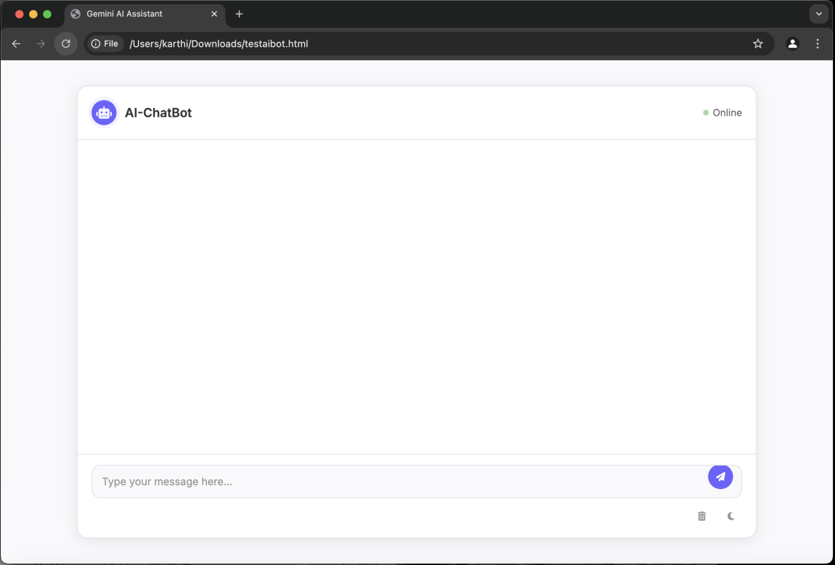

Description:

This image shows a screenshot of a web-based AI chatbot interface. The chatbot UI is clean and minimalistic, with a chat window allowing users to type messages. The header shows the title “AI-ChatBot” and an “Online” status indicator. The page is likely from a local HTML file (testaiBot.html), as seen in the browser’s address  
  
  
  
Output-2

DESCRIPTION:

* This image captures the conclusion section of a report on the AI chatbot project. It highlights the purpose and benefits of the project:
* Aims to create an engaging and responsive digital communication interface.
* Uses modern web technologies and modular design.
* Supports real-time feedback with animations and theme toggling.
* Ensures scalability and sets a foundation for future enhancements.
* Enhances user experience and bridges the gap between human and machine interaction.
* The background also shows the chatbot interface in action, answering questions like “Full form of HTML” and “Founder of Vignan University.”

CONCLUSION:

The AI-Bot project represents a significant step toward creating a seamless and engaging digital communication interface. By leveraging modern web technologies and a modular design approach, the system offers a responsive and intuitive user experience that adapts to various devices and user preferences. The integration of real-time feedback mechanisms, such as dynamic animations and theme toggling, enhances user engagement, while the scalable architecture sets the stage for future advancements. This project not only addresses the limitations of traditional chat interfaces but also paves the way for the incorporation of more sophisticated AI capabilities, ultimately bridging the gap between human and machine interactions with elegance and efficiency.

References:

Books:

* HTML & CSS: Design and Build Websites
* JavaScript: The Definitive Guide
* CSS Secrets

Websites:

* W3Schools
* GeeksforGeeks